Documentation of the I2C Address Translator(ATR)
Punyamurthy Sai Surya

About I2C:
Inter-Integrated Circuit (I2C) is a serial communication protocol that allows integrated circuits to communicate using a simple two-wire interface. These wires include Serial Data (SDA) for transferring information and Serial Clock (SCL) for timing, working in a master-slave setup. Each slave device on the bus has a unique address. The master uses this address to choose a device for data exchange. This addressing method lets you connect multiple peripherals to one bus without needing extra chip select lines. As a result, I2C is an effective way to interface with low-speed components like sensors, memory chips, and actuators in embedded systems.
Modules:
The I2C Address Translator (ATR) system comprises four key modules, each serving a distinct role in enabling I2C communication with address translation:
- Clock Divider: Generates a suitable I2C clock signal from the FPGA’s 50 MHz clock, ensuring compatibility with the I2C protocol’s timing requirements.
- I2C_Slave: Implements the slave device functionality, receiving and responding to I2C transactions initiated by the master through the ATR.
- ATR: Acts as the core address translation module, bridging the I2C master and a configurable number of slave devices by mapping a single master address to unique slave addresses.
- Testbench: Functions as the I2C master in simulations, generating test sequences to verify the ATR’s functionality, including address translation and data transfers.

ATR Architecture:
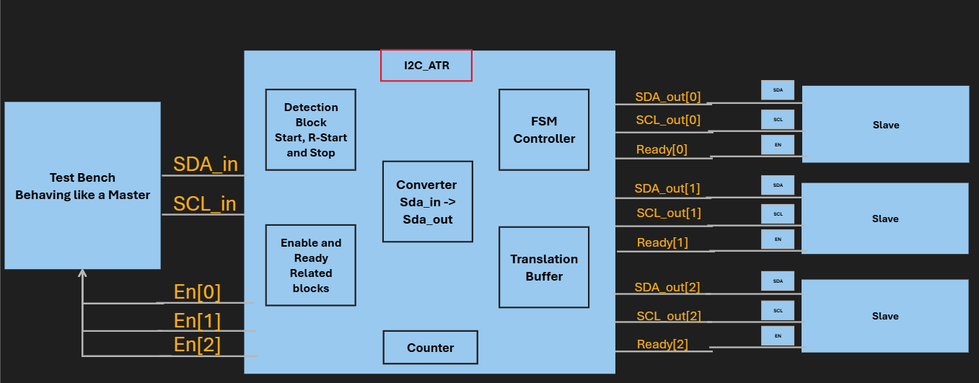
I²C ATR:
Between a single I²C master and up to N slave devices, the I²C ATR module serves as a transparent bridge or middleman. Address translation, which essentially maps a single master address to various physical slave addresses, is its main purpose. It ensures that communication is directed correctly by controlling the routing of SDA and SCL signals to the chosen slave based on the en input. This design enables a modular system in which the ATR manages the complexity of addressing numerous, possibly dissimilar slave components, while the master communicates using a single address.
Detection Block:
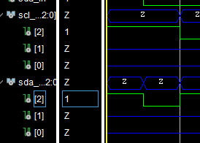
The I²C bus lines must be continuously monitored for particular protocol events by this block. It recognizes the RESTART condition (a new START within an active transaction) and the START condition (a high-to-low transition on SDA when SCL is high), also, it recognizes the STOP condition, which denotes the conclusion of a communication and is characterized by a low-to-high transition on SDA while SCL is high. Critical control flags (start_bit, r_st_bit, and stop) are produced by these detections, and they cause state changes in the main FSM Controller, which either start or stop transaction sequences. The figure disclosing the start condition.

FSM Controller:
The module's central logic, the FSM Controller, is a dual finite state machine (state_0, state_1) that coordinates the whole I²C communication sequence. To control the protocol flow, it methodically moves between specified states like READ_ADDR, ACK, WRITE_DATA, and READ. To ensure correct timing with the I²C standard, state transitions are synchronized to the SCL clock's negative edge. In order to coordinate address translation and data movement between the master and the chosen slave, this controller produces crucial signals like the ACK (acknowledge) and xor_flag.

Address/Data Translation Logic
The "ATR" (Address Translation) feature, which modifies the address and data being sent to the slave, is centered around this. It employs a bitwise XOR operation between a 7-bit translation_byte input and the incoming address/data from the master. A new, mapped address for the slave is essentially created by the translation_byte, which supplies the special pattern for the translation. By abstracting the physical addressing scheme from the primary controller, the ATR sends a translated address to the target slave, allowing the master to use a standard address.

Slave Selection and Routing :
Signal routing to and from the target slave device is managed by this block. It determines which of the three available slaves (en[0], en[1], or en[2]) is the active participant in the current transaction using the en input vector. It routes the master's SCL clock straight to the selected slave based on this selection. The SDA line functions as a smart switch for the I²C bus by conditionally passing the data, managing the data path during reads, and applying the address translation logic during write operations.

Counters:
Three key counters are used in the module, each of which has a specific function in transaction management. The count variable serves as the Address Bit Counter and is only used to track when the 7-bit slave address is received from the master during the READ_ADDR state. Reused in several states to count bits for the internal register address, data bytes being written, and data bytes being read, the count_1 variable acts as the main Data Bit Counter. Lastly, the internal_count manages multi-byte write sequences by acting as a Byte Counter and increasing after each data byte is successfully written. When combined, these counters give the FSM the exact timing and sequencing it needs to properly understand and produce the I²C protocol.
Buffer:
The buffer is an array with one 8-bit element for each of the N slave channels. Its purpose is to hold the translation key provided by the shared translation_byte input. When a specific channel is enabled via its en signal, the corresponding buffer element ont eh port translation byte goes to the Buffer. This stored value is then used during the address phase to perform the bitwise XOR operation, effectively remapping the slave address to the registers. This design allows a single, flexible input to configure the translation for any target slave device.

Working of FSM:
A Finite State Machine (FSM) that controls the I2C protocol forms the basis of your module. It controls the transaction flow uniquely by using two state variables, state_0 and state_1, to avoid multi-driven net issues and uses only the SCL clock received from the master to process the FSM. I2C write and read operations, including repeated start conditions, are supported by the FSM's design.

state_0: This handles transactions initially. Until the bus detects a START condition, it stays in an IDLE state. It switches to the READ_ADDR state upon detection to record the R/W bit and the original 7-bit slave address. After receiving the address, it sets state_1 to activate the main FSM and then returns to the IDLE state.

state_1: Following the initial address phase, this is the primary FSM controller that controls the remainder of the I2C communication sequence. To handle data transfers (both writing to and reading from the slave), read register addresses, and make acknowledgments, it moves through several states.

Significance of each State in the FSM:
On the SCL clock's negative edge (negedge scl_o), the FSM transitions. The following occurs in each of the main FSM's primary states (state_1):
- READ_ADDR: Any I2C transaction starts in the READ_ADDR state. It is managed by the state_0 variable and activates as soon as the bus detects a START condition, which is defined as SDA falling while SCL is high. Its only function is to record the first byte that the I2C master sends, which includes the final Read/Write bit and the 7-bit slave address. It samples one bit from the sda_in line by incrementing a counter (count) on each falling edge of the clock (negedge scl_o). Address translation logic (sda_in ^ buffer[...]) on the output is enabled during this period due to the activation of the xor_flag. The state_0 machine has finished its job once the eighth bit has been captured. In order to start the acknowledgement process, it then executes a crucial "hand-off" by changing the main FSM (state_1) to the ACK1 state before going back to the IDLE state.

- IDLE: The state by default. Here, the machine waits for state_0 to initiate a new command sequence following a start condition. Every counter and flag has been reset.

- ACK1: This state is used to generate the first acknowledgement (ACK) bit, which verifies that the slave address and the WRITE/READ bit that was received, after state_0 has received it. The target register address is then read right away.

- ADDRESS_READ: The FSM clocks in at this state using the 8-bit internal register address that the master sends; it is used to tell the slave where to store the data.

- ACK2: This state creates a second ACK to verify that the 8-bit register address was received completely before getting ready for the data writing stage.

- WRITE_DATA: It is a 9-bit register. In the case of write, it uses the register bits from 8 to 1. To receive multiple 8-bit data bytes from the master, the FSM enters this state. For multi-byte write operations, it stays in this state and processes each byte separately. Further, it is also used to detect the Repeated Start signal, which comes from the slave. After detection, it uses the register values from 7 to 1 for comparing the slave address, and then it also further stores the read bit in this, then raises a flag to say that it has detected the repeated start. Further detection it raises the xor_flag, which is used for the address translation mechanism.

- ACK3: After every data byte is successfully received, this state sends an ACK. It's a critical decision point: it returns to WRITE_DATA for the subsequent byte if a repeated start flag is not detected, otherwise it moves to the READ state.

- READ: After several starts, this state is entered. To send data to the master, the module here takes control of the SDA line from the master. Multiple 8-bit data bytes will be sent by the slave until the master sends the NACK(negative Acknowledgment).

- ACK4: The FSM enters this state to wait for the master's acknowledgement after sending a data byte. The FSM goes back to the READ state to send another byte if the master sends an ACK. The read sequence is over if it sends a NACK.

Implementation of Address translation:

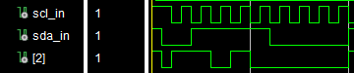
The operation is supervised by a finite state machine that captures and alters the first address byte of an I2C transaction.
Channel Selection: The master activates one of the three slave channels via the en input signal, which is the beginning of the operation. This will decide the communication with the physical slave that is routed to.
Address translation
If the slave address is 1101000, and if we input 0111100, it will get translated by the ATR using the inputted translation byte
START and Address Interception: The master generates a START condition that counts the module. The master is sending the 7-bit slave address, and the module's FSM is transitioning to the READ_ADDR state.
On-the-Fly Translation: The module is now intercepting the bits of the address going in from the master on the sda_in line, only one at a time. It extracts this bit's corresponding bit from the translation_byte and performs a bitwise XOR operation between these two bits. The sent bit on the sda_out line is the immediate result of this operation, which will be the selected slave's input. Furthermore, the translation byte can be able to change from transaction to transaction, attaining the runtime configurable operation.
Transaction Passthrough: The module disables the xor flag once the 7-bit address and the R/W bit are translated. It then enters a passthrough mode where it just forwards all further communication, like the register address, data bytes, and acknowledgements, between the master and the selected slave of choice.
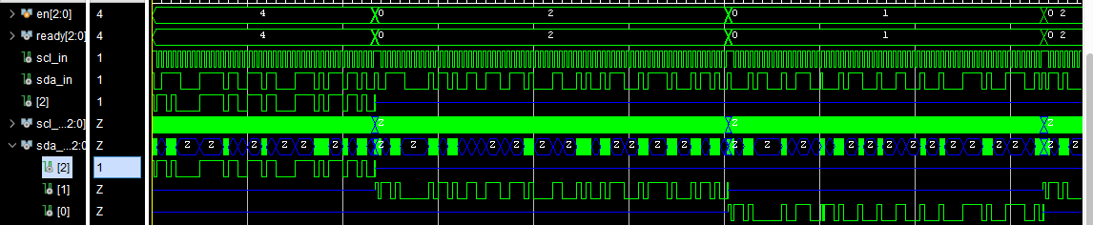
Multi-byte transaction alongside activating the multiple channels in the runtime without compiling
Multi-Byte Translation: The module is compatible with N number of bytes for both write and read operations, and it will get reset for the next operation after the detection of the stop condition.

Design Challenges Faced
1. Implementation of Multi-Byte Transaction
Issue: The I2C protocol provides the option for the master device to write or read several bytes of data continually as one transaction. It was a difficult task to come up with a design for an FSM that could manage an indefinite flow of bytes for both transactions without cutting off the process in between. Besides, the machine was required to loop back around the process once for each byte to correctly register the byte and the corresponding acknowledgement.
Solution: A state loop concept was employed to take care of the above issue by dividing the main FSM (state_1) into different segments:
For Multi-Byte Writes: The FSM goes into the state of WRITE_DATA from where it takes in 8 bits of data. The next state is ACK3, where it sends an acknowledgement. Now, instead of stopping, the logic in ACK3 checks for a repetitive start signal. In case the logic finds no signal (r_st == 0), it then transitions to WRITE_DATA directly to take the next byte. This cycle WRITE_DATA -> ACK3 -> WRITE_DATA continues until a STOP signal from the master is given.
For Multi-Byte Reads: The FSM comes to a state of ACK4 after giving out a byte of data in the READ state, to find out if the master acknowledges. If the master sends an ACK (SDA low) the FSM goes back to the READ state for the next byte. This READ -> ACK4 -> READ cycle goes on until the master sends a NACK (SDA high) that signifies the end of the read sequence.

2. FSM State Transition for Asynchronous Events && Multi-Driven Net Errors
Issue: The I2C START condition is an asynchronous event (SDA falling while SCL is high) and is not synchronized with the SCL clock. A single, purely synchronous always @(negedge scl_o) block cannot reliably detect this condition and is thus unable to transition from IDLE to READ_ADDR in time to catch the first address bit on the first clock edge. This timing mismatch results in the initial address byte being overlooked.
Solution: A two-state-variable approach was deployed to connect the asynchronous and synchronous areas.
state_0: This particular variable serves as the chaotic "entry master" for the system. It is run by a combinational always @(*) block. An asynchronous edge-triggered block sees the start_bit. This instantaneously leads the combinational block to change state_0 from IDLE to READ_ADDR, thus getting the FSM ready for the address capture even before the first clock edge comes.
state_1: This is the chief, synchronous FSM controller, ruled inside the always @(negedge scl_o) block. It merely assumes the transaction after state_0 has properly managed the initial START condition. This design guarantees that there is no data loss and that the handling of asynchronous bus events is neatly separated from the synchronous protocol logic.
3. Exact Bidirectional SDA Line Control
Problem: The ATR, acting as a mediator, must, without any hitches, alternate between eavesdropping on the sda_in line (when the master is sending data) and driving the sda_out and sda_in lines (during address translation, reads, or acknowledgements). The timing coordination of this whole up-and-down control was the main problem that led to bus contention, which is where both the master and the ATR try to drive the line simultaneously.
Solution: The SDA lines are under strict control, which is achieved by employing a mix of control flags and bit-by-bit counters on the FSM's state logic.
Flags, which include ACK, read, and xor_flag, are triggered according to the current FSM state. The flags are then used as the first enable signals in the tri-state drivers' assign statements. For instance, assign sda_in = ((ACK || read) ...), which means that the ATR is going to drive the master's bus only during an ACK or a read.
The counters like count and count_1 are used to keep track of the number of clock cycles (bits) that have gone by. This way, the ATR is going to be the one who drives the bus for the exact time needed (e.g., for one bit during an ACK, or for eight bits during a data read). At other times, the outputs are set to high impedance (1'bz), thus giving the control of the bus to the master correctly.

Reports by VIVADO:
Synthesis Reports:
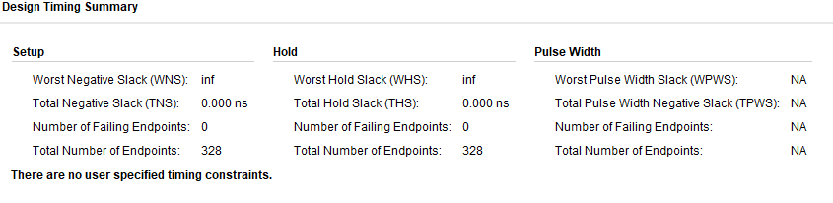
Power:
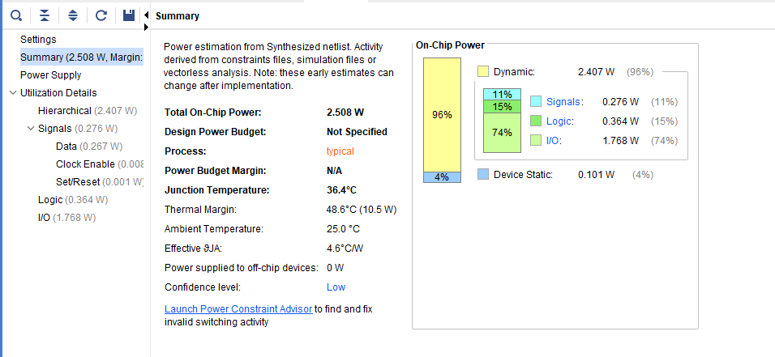

Utilization:
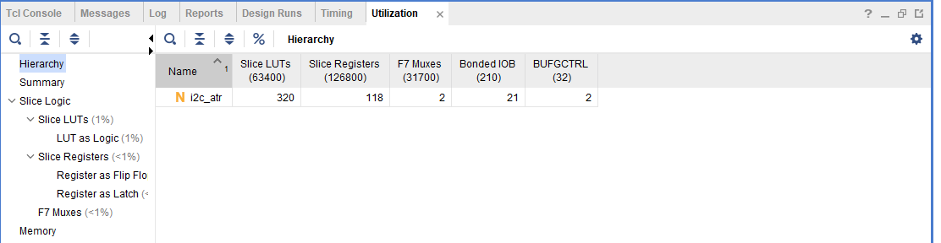

Implementation:
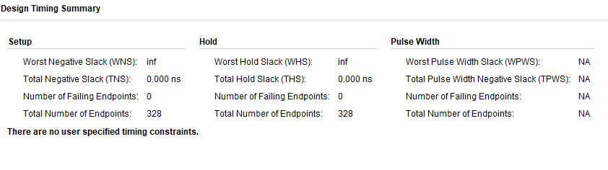
Utilization:
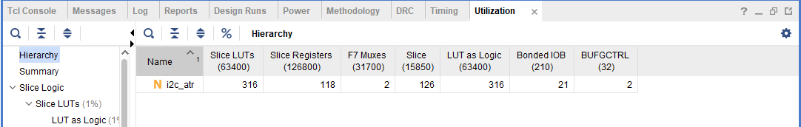

Power:
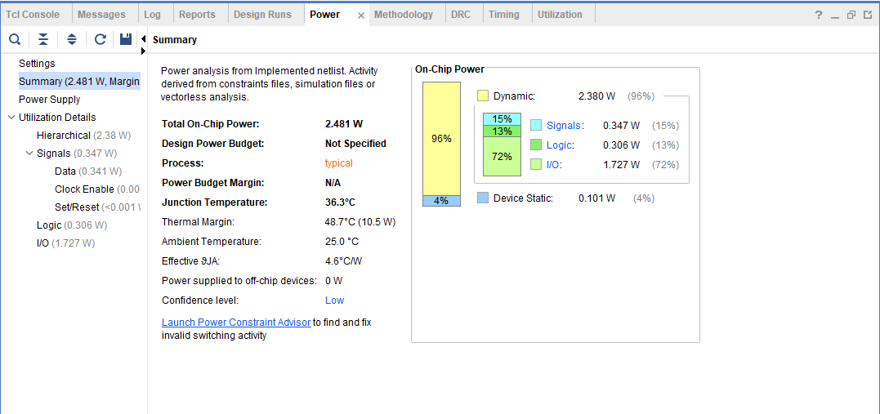

Bit Stream:
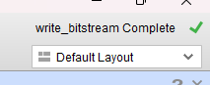

Functional Verification:
The ATR’s functionality was verified using a testbench acting as the I2C master. The test involved executing multiple write and read operations consecutively, transmitting approximately 512 bytes of data in random order to and from the slave devices. The verification process employed a scoreboard analogy, where transmitted data was compared against the data from the DUTs to detect mismatches. The results showed zero mismatches, confirming the ATR’s reliability in handling multi-byte transactions, address translation, and data integrity across the configurable N-port architecture. This extensive testing validates the design’s compliance with the I2C protocol and its enhanced features, including the single translation byte mechanism.
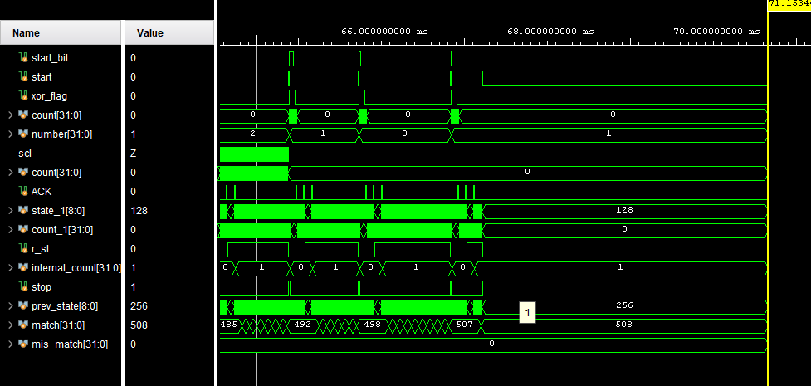

References:
The I2C Address Translator (ATR) was inspired by publicly available datasheets and application notes from Analog Devices. These resources helped explain the I2C protocol and address translation methods used in their I2C multiplexers and translators. Texas Instruments' documentation on I2C was also consulted to understand protocol timing and how slave devices behave. This design builds on those references with original improvements. It supports a configurable number of slave ports (N ports) instead of a fixed configuration, and it uses a single translation byte for all ports, which increases flexibility and resource efficiency. The implementation in Verilog/VHDL, the finite state machine, and the system architecture are original designs created to meet the project's needs while following the I2C standard.

